PROJECT DEVELOPMENT PHASE

SPRINT 4

|  |  |
| --- | --- |
| TEAM ID | PNT2022TMID12755 |
| TEAM LEADER | NAVIALAGAN P(710719106051) |
| TEAM MEMBERS | * HARISH G(710719106023) |
|  | * HARSHA VARTHAN S(710719106024) |
|  | * JAWAHAR S(710719106028) |
| TITLE | Signs with Smart Connectivity for Better Road |

# Objective :

**Signs with smart connectivity for Better road safety**

>> To replace the static signboards, smart connected sign boards are used.

>> These smart connected sign boards get the speed limitations from a web app using weather API and update automatically.

>> Based on the weather changes the speed may increase or decrease.

>> Based on the traffic and fatal situations the diversion signs are displayed.

>> Guide(Schools), Warning and Service(Hospitals, Restaurant) signs are also displayed accordingly.

>> Different modes of operations can be selected with the help of buttons.

# Code for Registration and Login Credentials : ( index.html )

<!DOCTYPE html>

<html> <head>

<style> body

{

background-image : url('https://img.freepik.com/premium- vector/lilacabstract- background_126980-527.jpg?w=996');

background-repeat : no-repeat; background-attachment : fixed; background-size : 100% 100%;

}

</style>

<base target = "_top">

<script> function AddRow()

{ var usernamee = document.getElementById("usernamee").value; var passwordd = document.getElementById("passwordd").value; var email

= document.getElementById("email").value; var phone = document.getElementById("phone").value; if(usernamee==""||passwordd==""||email==""||phone=="")

{

return false;

} else { google.script.run.AddRecord(usernamee,passwordd,email,phone)

;

document.getElementById("page2_id1").className="page2_id1-off"; document.getElementById("page3_id1").className="page3_id1";

} }

function LoginUser()

{

var username = document.getElementById("username").value; var password

= document.getElementById("password").value; google.script.run.withSuccessHandler(function(output)

{

if(output=='TRUE')

{

var url1 = 'https://node-red-vygyh-2022-11-04.au-

syd.mybluemix.net/ui/#!/0?socketid=kVaDwxl44Sp25mOZAAAX'; var winRef = window.open(url1); winRef?google.script.host.close()

:window.onload=function()

{ document.getElementById('url').href=url1;

} }

else if(output=='FALSE')

{

document.getElementById("errorMessage").innerHTML="Invaliddata"; }

}).checkLogin(username,password);

}

function function1()

{

document.getElementById("page1_id1").className="page1_class1-off"; document.getElementById("page2_id1").className="page2_id1"; }

function function2()

{ document.getElementById("page2_id1").className="page2_id1off"; document.getElementById("page3_id1").className="page3_id1";

}

function function3()

{ document.getElementById("page3_id1").className="page3_id1off"; document.getElementById("page1_id1").className="page1_id1"; }

</script> <style>

/*page1*/

.page1_class1-off

{

display : none;

}

/*page2*/

.page2_class1

{ display :

none; }

.page2_id1-off

{ display :

none; }

/*page3*/

.page3_class1

{ display :

none; }

.page3_id1-off { display : none; } input[type=text] : hover

{

border-bottom : 2px solidblack;

}

input[type=number] : hover

{

border-bottom : 2px solidblack;

}

input[type=password] : hover

{

border-bottom : 2px solidblack;

}

</style>

<meta name="viewport" content="width=device-width,initial-scale=1.0">

</head>

<body><center><h1>Signs with smart connectivity for better road safety<h1> </center><br><br>

<!--page1-->

<center>

<div class="page1_class1" id="page1_id1" style="background-image: url('https://media.istockphoto.com/id/1302561463/photo/holographiciride scent-background-unicorn- colorful-rainbow-foil-abstractbeautiful-

rainbow.jpg?b=1&s=170667a&w=0&k=20&c=BXTMLyLQNIqvm2od1KerrL5hPVHbjBf5eh hN5sxlJNE=');border:1px solid gray;border-radius: 20px;width:

250px;padding-top:10px;padding-bottom: 20px;padding- left:20px;paddingright: 20px;"> <h1>Login</h1>

<input type="text" id="username" placeholder=" Enter the Username" style=";outline: none;border-top: none;border-right: none;border-left: none;font-align:centre;text-transform: none;font:monospace;fontsize:1.2em ;border-bottom: .2rem solid rgba(222, 214, 223, 0.3);margin:1rem 0;height:2rem;font:monospace;width:90%;"/><br> <input type="password" id="password" placeholder=" Enter the Password" style="border-top: none;font-align:centre;border-right: none;borderleft: none;margin:1rem 0; height:2rem;font-size: 1.2rem;border-bottom:

.2rem solid rgba(222, 214, 223, 0.3);text-transform: none; outline: none;font:monospace;width:90%;"/>

<br><span id="errorMessage" style="color:red"></span><br>

<input type="submit" class="button" value="Login" onclick="LoginUser()" style="float: centre;padding-top: 1px;padding-bottom: 1px;padding-left:

10px;padding-right: 10px;font-size: 1.2em;"/><br><br><br><br>

<b>If you don't have an account.,</b>

<input type="button" onClick="function1()" value="Register" style="margin-top:10px;font- weight:bold;"/>

</div>

<!--page2-->

<div class="page2_class1" id="page2_id1" style="background-image: url('https://media.istockphoto.com/id/1302561463/photo/holographiciride scent-background-unicorn- colorful-rainbow-foil-abstractbeautiful-

rainbow.jpg?b=1&s=170667a&w=0&k=20&c=BXTMLyLQNIqvm2od1KerrL5hPVHbjBf5eh hN5sxlJNE=');border:1px solid gray;border-radius: 20px;width:

250px;padding-top:10px;padding-bottom: 20px;padding- left:20px;paddingright: 20px;"> <h1>Register</h1>

<input type="text" id="usernamee" placeholder=" Enter the Name" style=";outline: none;border-top: none;border-right: none;border-left: none;font-align:centre;text-transform: none;font:monospace;fontsize:1.2em ;border-bottom: .2rem solid rgba(222, 214, 223, 0.3);margin:1rem 0;height:2rem;font:monospace;width:90%;"/><br> <input type="password" id="passwordd" placeholder=" Enter the Password" style=";outline: none;border-top: none;border-right: none;border-left: none;fontalign:centre;text- transform: none;font:monospace;fontsize:1.2em ;border-bottom: .2rem solid rgba(222, 214, 223, 0.3);margin:1rem 0;height:2rem;font:monospace;width:90%;"/><br>

<input type="text" id="email" placeholder=" Enter the Email" style=";outline: none;border-top: none;border-right: none;border-left: none;font-align:centre;text-transform: none;font:monospace;fontsize:1.2em ;border-bottom: .2rem solid rgba(222, 214, 223,

0.3);margin:1rem 0;height:2rem;font:monospace;width:90%;"/><br><br><br>

<input type="submit" value="Create" onClick="function2()" style="float: centre;padding-top: 1px;padding-bottom: 1px;padding-left: 10px;paddingright: 10px;font-size: 1.2em;"/><br><br>

</div>

<!--page3-->

<div class="page3_class1" id="page3_id1" style="background-image: url('https://media.istockphoto.com/id/1302561463/photo/holographiciride scent-background-unicorn- colorful-rainbow-foil-abstractbeautiful-

rainbow.jpg?b=1&s=170667a&w=0&k=20&c=BXTMLyLQNIqvm2od1KerrL5hPVHbjBf5eh hN5sxlJNE=');border:1px solid gray;border-radius: 20px;width:

250px;padding-top:10px;padding-bottom: 20px;padding- left:20px;paddingright: 20px;">

<center><h2>Thank you for registered !!<br><br></h2></center>

<input type="submit" onClick="function3()" value="Login" style="float: centre;padding-top: 1px;padding-bottom: 1px;padding-left: 10px;paddingright: 10px;font-size: 1.2em;"><br><br>

</div>

</center>

</body>

</html>

# ( Code.gs )

function doGet(e)

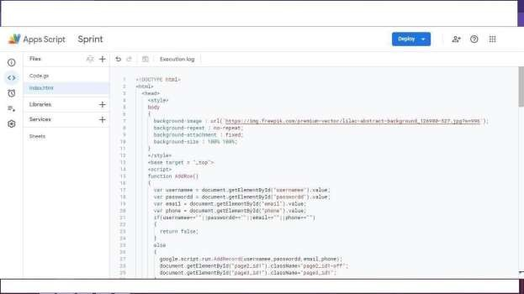{

# ( Code.gs )

function doGet(e)

{

var x = HtmlService.createTemplateFromFile("index.html"); var y

= x.evaluate(); var z =

y.setXFrameOptionsMode(HtmlService.XFrameOptionsMode.ALLOWALL)

; return z; }

function checkLogin(username, password) {

var url =

'https://docs.google.com/spreadsheets/d/1IB2nLiYrCbq71P047pn yj9_zDXDoRsIhBEeY74aQl0o/edit#gid=0'; var ss = SpreadsheetApp.openByUrl(url);

var webAppSheet = ss.getSheetByName("DATA"); var getLastRow

= webAppSheet.getLastRow(); var found_record=''; for(var i=1;i<=getLastRow;i++)

{

if(webAppSheet.getRange(i,1).getValue().toUpperCase() == username.toUpperCase() &&

webAppSheet.getRange(i,2).getValue().toUpperCase()==password

.toUpperCase())

{

found_record='TRUE';

} }

if(found_record=='')

{

found_record='FALSE';

}

return found_record;

}

function AddRecord(usernamee,passwordd,email,phone)

{ var url

=

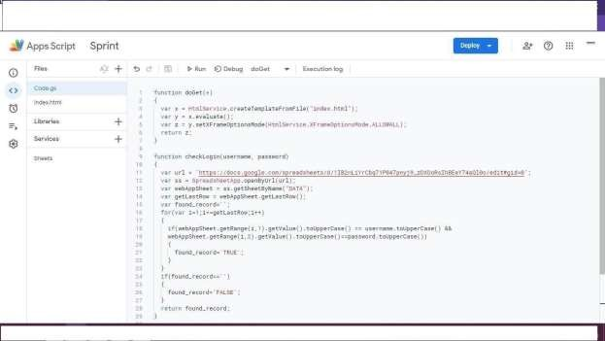'https://docs.google.com/spreadsheets/d/1IB2nLiYrCbq71P047pn yj9_zDXDoRsIhBEeY74aQl0o/edit#gid=0'; var ss = SpreadsheetApp.openByUrl(url); var webAppSheet = ss.getSheetByName("DATA"); webAppSheet.appendRow([usernamee,passwordd,email,phone]);

# Registration and Login Form :

